## Repainting Bug(Fixed)

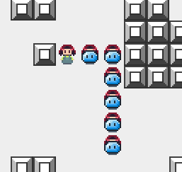

On Windows machines (confirmed on Windows 7) using JPanel doesn’t result in repainting correctly.

This can be fixed by a call to

super.paint(g);

in the paint() method, or by painting the background white with

g.setColor(Color.WHITE);

g.fillRect(0, 0, getWidth(), getHeight());

Strangely, this is not an issue on OS X.

## Player attacking enemies Bug (non-issue)

When there are two enemies next to the player it attacks the one farthest away.

Was never actually a bug. It looks like the player kills the farthest one away but in reality the farther slime move forward one space to attack the player.

## Unconnected Room Bug - aka “Closed Loops” (Somewhat fixed)

I've ensured that the player can always get to a staircase. However, there may still be rooms that aren't connected.

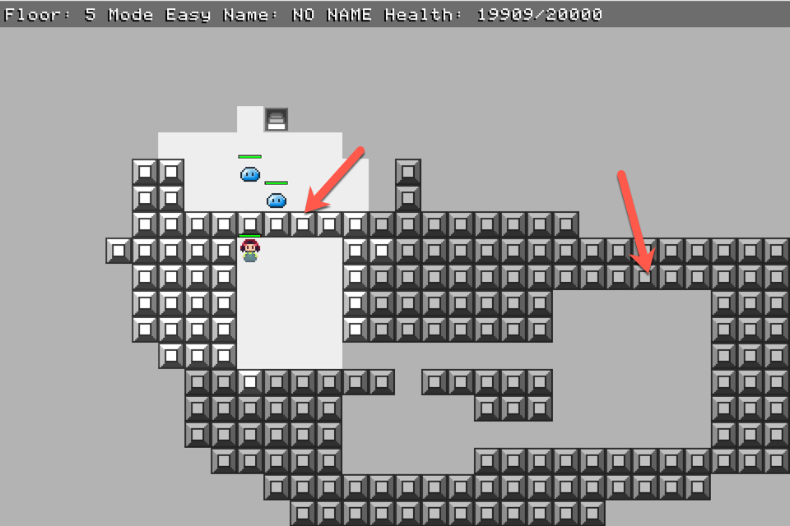

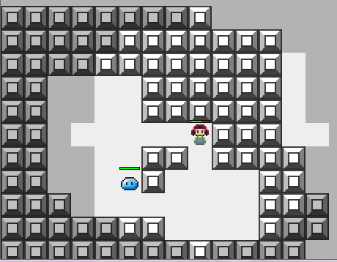

## Balancing issues

